
YEAR 10 SCIENCE

PHYSICAL SCIENCES 1

FORCES AND MOTION

NAME:

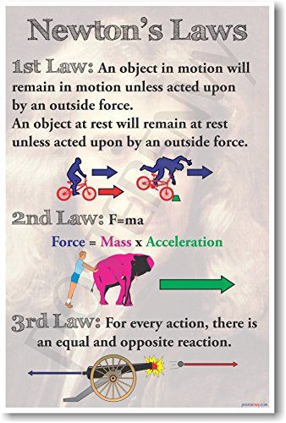

DISTANCE AND DISPLACEMENT

Distance (d): how far a body moves in any direction.

e.g. The diagram below shows the movement of a student between home and school.

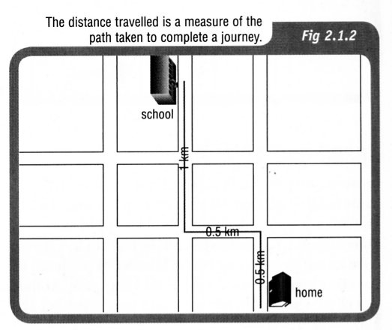

The distance travelled is 2.0 km.

Displacement (s): change of position of a body from the start of the motion to the finish of the
motion, and is in a particular direction.

e.g. The diagram below shows the displacement of the student when travelling to school.

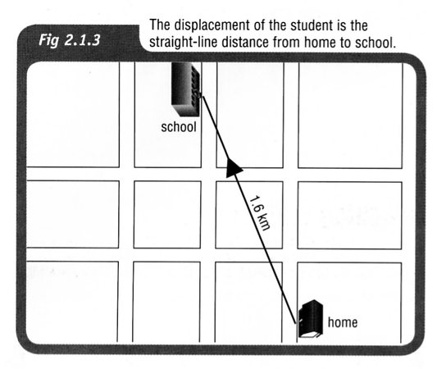

The straight-line distance is 1.6 km. No direction is indicated in the diagram.

If the distance you walk from home to school is 2.0 kilometres, the distance you travel from home to school and back home again is 4.0 kilometres. If you start at home and finish the day’s journey at home, your starting and finishing points are the same position (home) then your displacement for the day is actually 0 km.

In Physics, distance is known as a scalar quantity and displacement is a vector quantity.

Vectors have a direction associated with them.

SPEED AND VELOCITY

Speed: distance moved per unit time.

where speed = how fast the object travels for the entire journey (m/s)
d = distance travelled for the entire journey (m)
t = time taken for the entire journey (s)

Speed is a scalar quantity as direction is not important. Velocity is a vector quantity and has a direction involved.

Use the triangle shown to help calculate speed.

sp
d
t

Velocity: displacement moved in a given direction per unit time.

where v = velocity in a given direction (m/s)
s = displacement in a given direction (m)
t = time taken to move in a given direction (s)

Use the triangle shown to help calculate velocity.
v
s
t

Note
The units for speed and velocity are metres per second (m/s), not km/h.

To convert km/h to m/s, divide the reading in km/h by 3.6.

Example 1

Example 2

A cyclist rides along a coast road that meanders and changes direction constantly. He covers a distance of 5.80 km in a time of 12.2 minutes. However the straight line distance between his start and finish points is only 4.20 km in a direction due south. Calculate:

(a) the average speed of the cyclist.
(b) his average velocity.

(a) (b)

The direction is important - make sure you put it in!

Worksheet - Distance Versus Displacement

1. Map 171 - use the scale to work out the distance and displacement from HCC to the roundabout at The Boulevarde and Pinaster Parade. Check your measurements using Google maps.

Working

2. Map 185 - use the scale to work out the distance and displacement from Whitfords City shops (Endeavour Road entrance) to the roundabout at Whitfords Avenue and Angove Drive. Check your measurements using Google maps.

Working

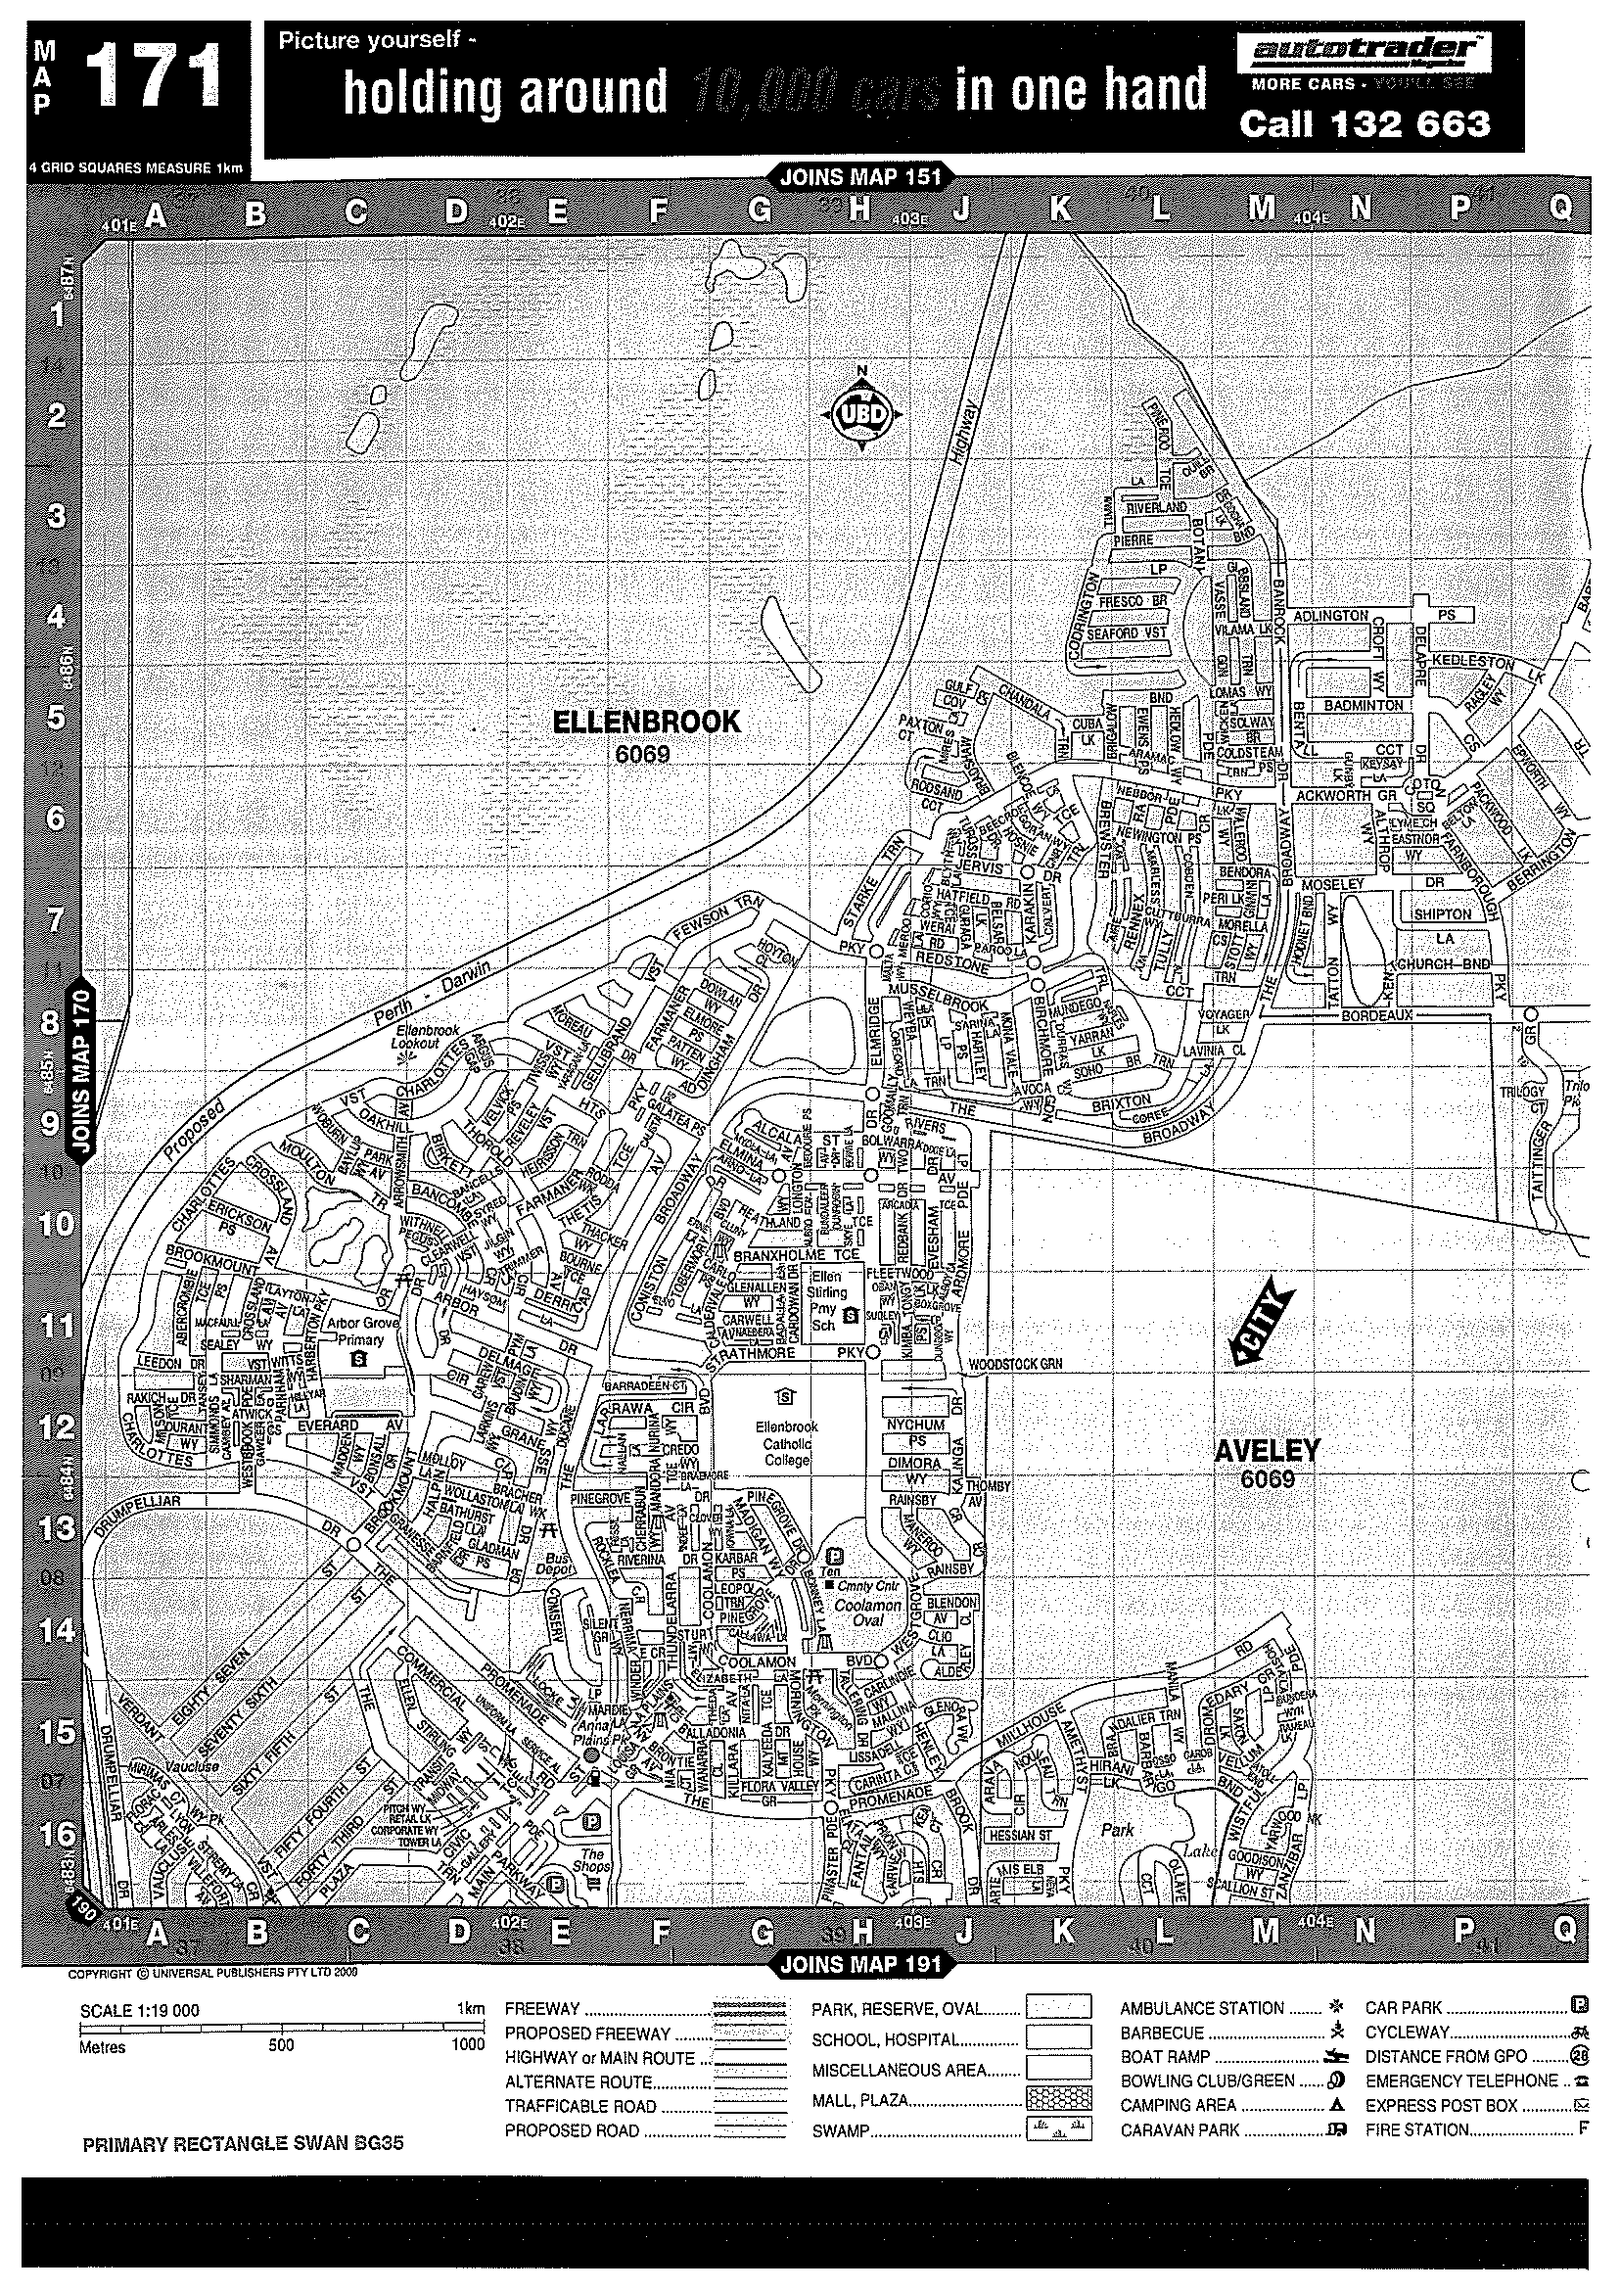
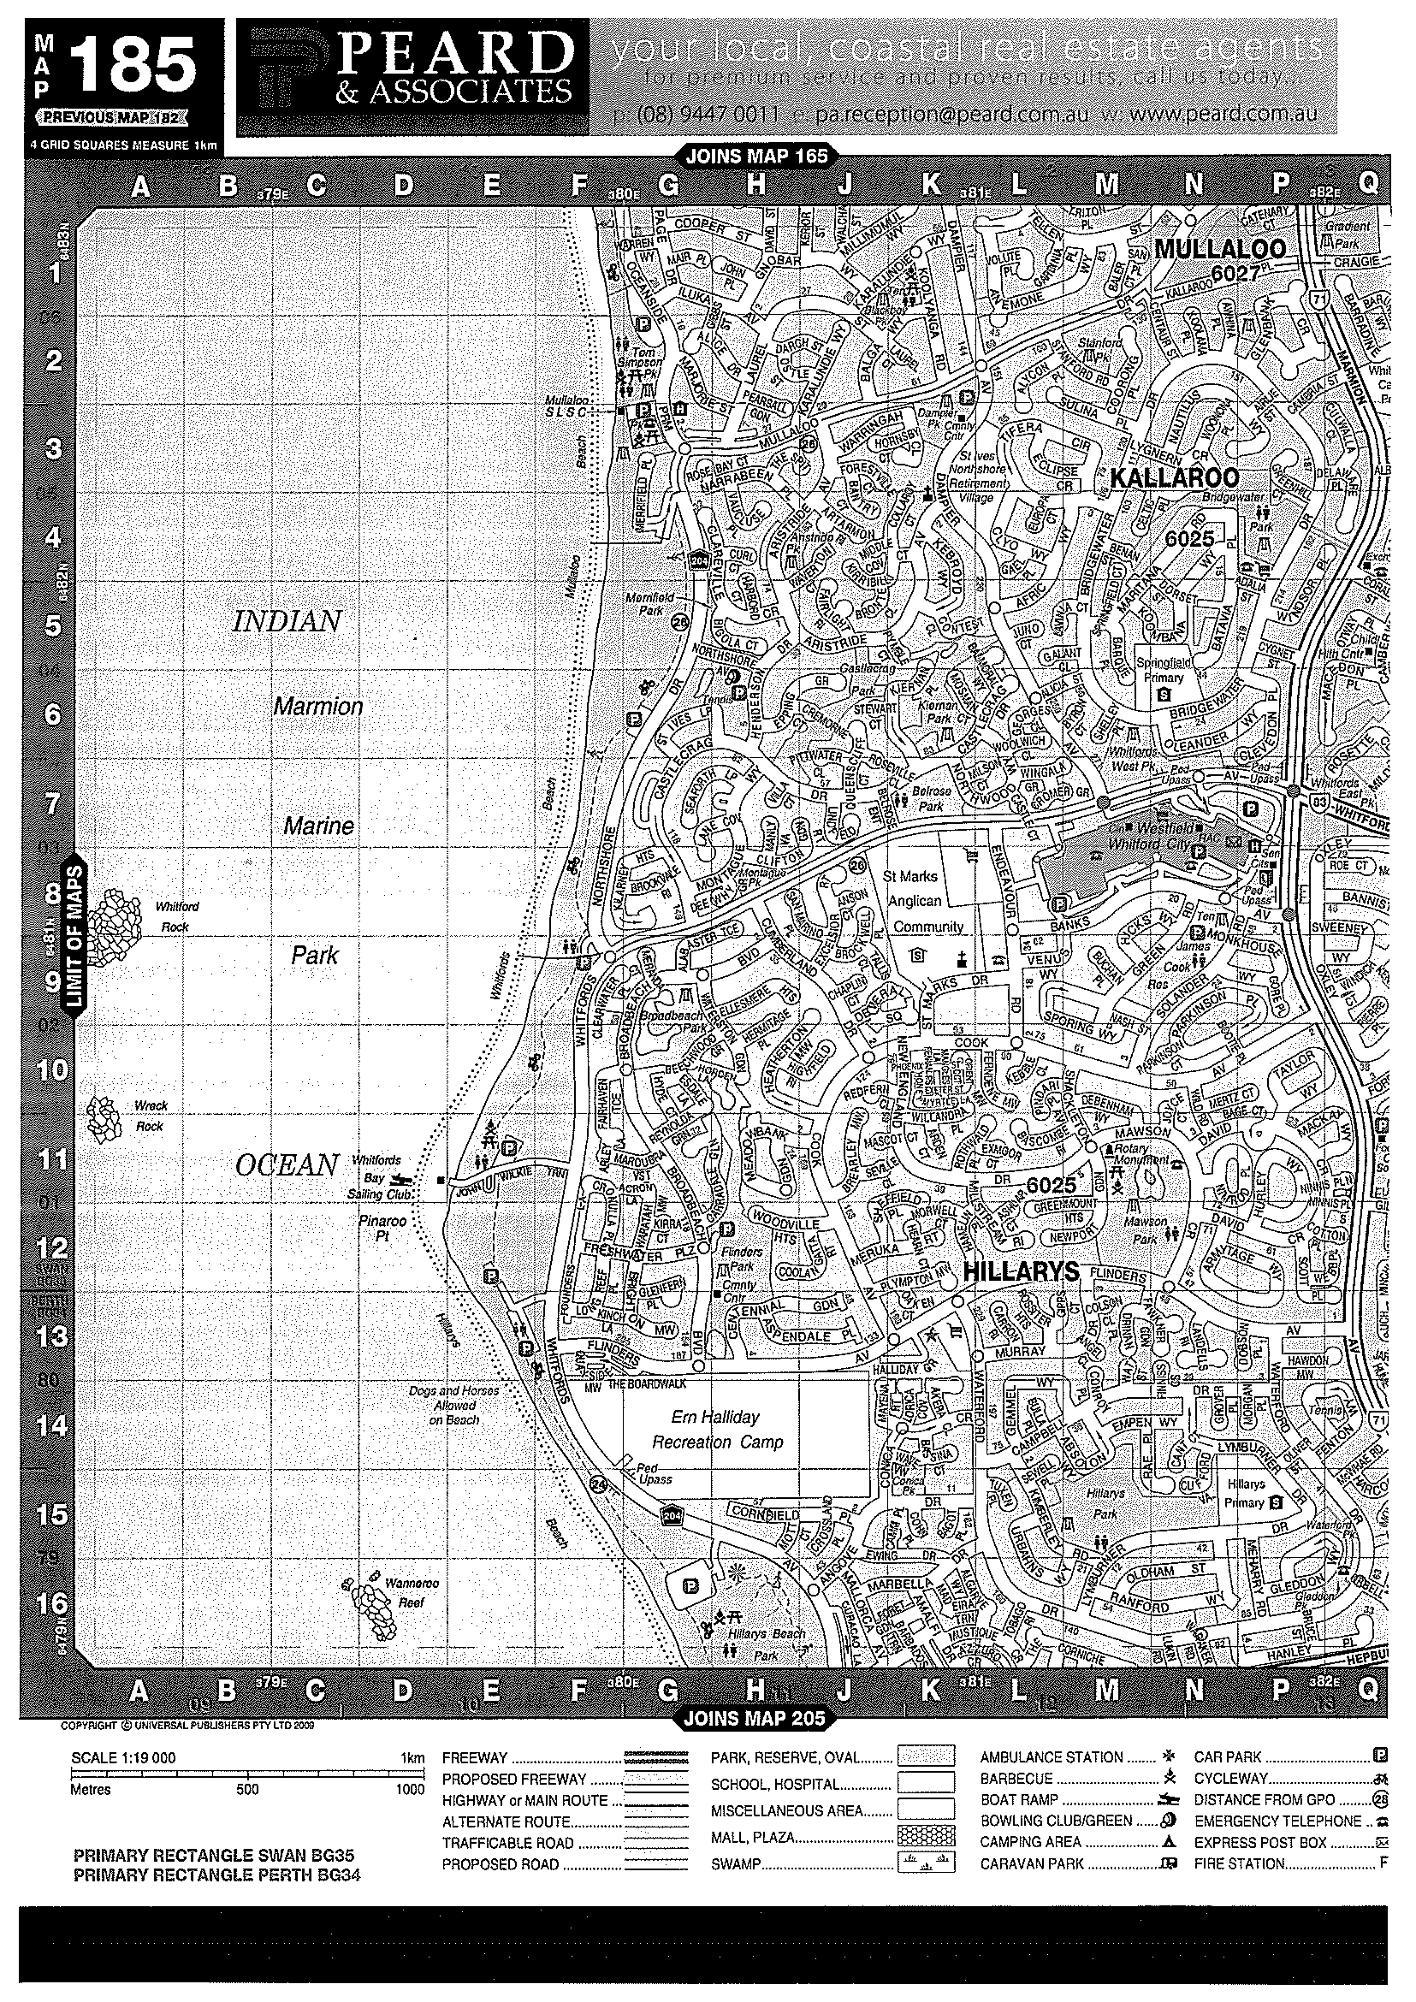
CHAPTER 8: Forces, energy and motion
Worksheet 8.1

Speed and velocity
Student: Class:

Calculating average speed
1. The average speed (v) for a journey is calculated using the formula:
v = | d
 | t
where d = distance travelled and t = time taken.
Complete the following table. Make sure you include the appropriate units for each quantity.
Distance travelled | Time taken | Average speed
100 m | 20 s
3 km |  | 60 km/h
 | 15 s | 20 m/s
2 km |  | 25 m/s

Average speed and average velocity
2. Two vehicles (X and Y) travel from A to C along different paths as shown in the diagram (not drawn to scale). X travels along the path ABC and vehicle Y travels along AC. The triangle ABC is a right-angled triangle. A is north of B.
 |  | 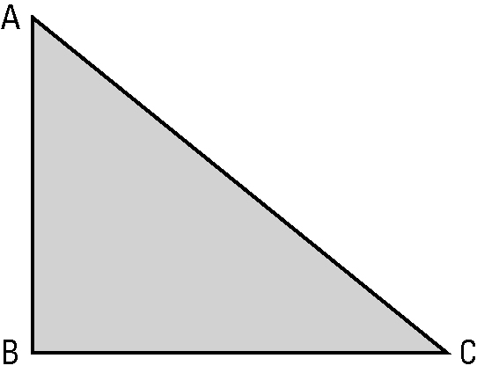 | 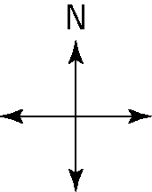
Both vehicles take 70 s for the trip.
Perform the necessary calculations to complete the following table.
Average speed of X | Average velocity of X | Average speed of Y | Average velocity of Y

TICKER TIMERS

A ticker timer will mechanically record 50 dots every second.

∴ 1 dot spacing represents 1/50th of a second = 0.02 s

Visually, the ticker tape shows whether the motion represented is constant speed or acceleration.

. . . . . . . . . . . . . . . . . . Constant speed -
dots evenly spaced.

. . . . . . . . . . . . . . . Acceleration -
dots get further apart.

Calculations

Constant speed

• Choose 1 dot as your start point.
• Count 4 dots from this point- this represents 0.10 seconds.
• Measure the distance from the start to the fifth dot.
• Calculate the speed or velocity using .
t = 0.08 secs

. . . . . . . . . .

d = 11.3 cm
Acceleration

• Choose 5 dots near the start of the tape - this represents
4 dot spacings = 0.08 seconds.

• Measure the distance for the 5 dots and calculate the average speed as above. This is the initial velocity (u).

• Select 5 dots near the end of the tape. Measure the distance for these and calculate the average speed - this is the final velocity (v).

• Mark the middle dot of the "u" section and middle dot of the "v" section.

Count the number of dot spacing between them and multiply by 0.02 seconds to work out the time.

• Calculate the acceleration using .
u
v

d = 4.3 cm
t = 0.08 s
d = 15.9 cm
t = 0.08 s

. . . . . . . . . . . . . . . .

t = 11 spacings
= 11 x 0.02
= 0.22 secs

CHAPTER 8: Forces, energy and motion
Worksheet 8.2

Ticker tapes
Student: Class:

Describing motion
1. For each ticker tape shown, describe the motion of the body to which the tape was attached.
The left-hand dot is at time zero.
(a)


(b)


Measuring speed
2. The time between each of the dots on the following ticker tape is 0.02 s.

(a) Calculate the average speed of the object to which the tape was attached for each time interval. Express your answers in mm/s.
Interval | Distance between dots (mm) | Average speed (mm/s)
AB
BC
CD
DE
EF
FG
(b) Describe the motion of the object to which this tape was attached.

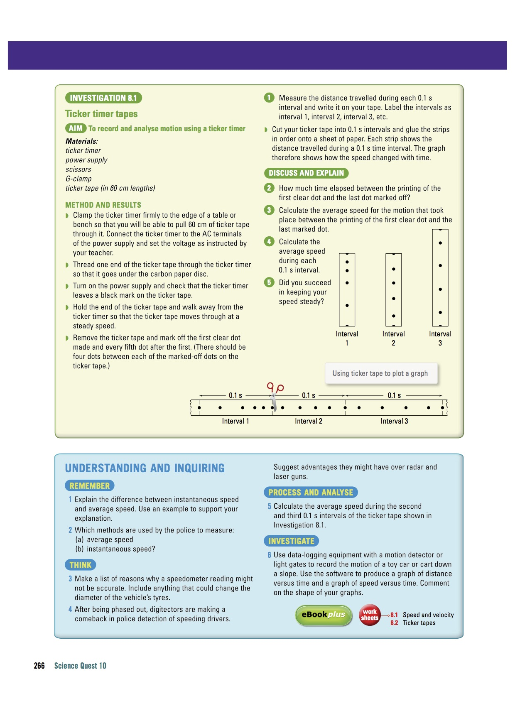
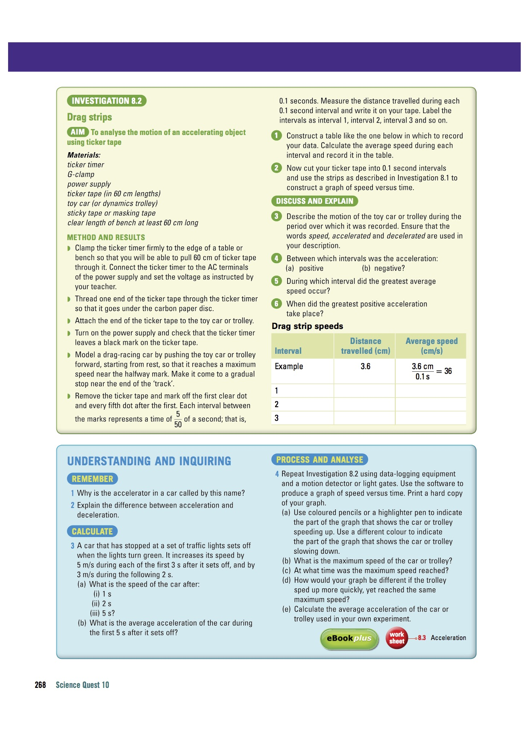

ACCELERATION

Acceleration (a): rate of change of velocity in a given direction.

It is a vector quantity and is calculated by the equation:

where a = acceleration in a given direction (m/s²)
u = initial velocity of the object (m/s)
v = final velocity of the object (m/s)
t = time taken for the change in velocity to occur (s)

This equation can also be written as:
v = u + at

Note
• When solving problems, pick one direction as the positive direction.

• Any vector in this direction is a positive value.

• Any vector in the opposite direction is a negative value.

Examples

1. A car moving at 30.0 km/h along a straight road accelerates uniformly to
70.0 km/h in 12.0 s. Calculate the acceleration experienced.

2. A car moving at 70.0 km/h along a straight road brakes suddenly to avoid a dog that ran onto the road. It reduced its velocity to 15.0 km/h in 2.97 s and successfully missed the animal. Calculate the deceleration of the car.

Note

The negative answer to the above example indicates that the acceleration is in the opposite direction to the direction chosen as positive (i.e. backwards).

Hence deceleration is an acceleration in the backwards direction, causing the car to slow.

If any answer to a problem is negative (and you are sure of your mathematics!), it means the vector is acting in the opposite direction to the positive direction you chose.

CHAPTER 8: Forces, energy and motion
Worksheet 8.3

Acceleration
Student: Class:
The velocities of two objects were recorded over 10-second time periods, as shown in the examples below.

Example: Gaining and losing speed
Time (s) | 0 | 1 | 2 | 3 | 4 | 5 | 6 | 7 | 8 | 9 | 10
Velocity  (m/s) | 0 | 2 | 4 | 6 | 8 | 10 | 12 | 11 | 10 | 9 | 8
1. (a) Use a spreadsheet application such as Excel to plot a line graph of this data.
(b) Format your graph. Ensure that the graph has a title and that each axis has a title and appropriate units. Use the printed graph to answer the following questions.
(c) Explain the shape of the graph.

(d) At the eight-second mark the object’s speed begins to decrease. If the object’s speed continues to decline at the same rate after ten seconds, at what time will its velocity be zero?

Example: Falling down
Time (s) | 0 | 1 | 2 | 3 | 4 | 5 | 6 | 7 | 8 | 9 | 10
Velocity  (m/s) | 0 | 9.8 | 19.6 | 29.4 | 39.2 |  | 58.8 |  | 78.4 |  | 98.0
2. (a) Examine the data table and determine the pattern in the data. Use this pattern to complete the table.
(b) Use a spreadsheet application such as Excel to plot a line graph of this data.
(c) Format your graph. Ensure that the graph has a title and that each axis has a title and appropriate units.
(d) Explain how this graph shows that falling due to gravity is an example of uniform acceleration.

(e) The slope of the graph is equal to the acceleration due to gravity. Determine the slope of the graph in m/s².

Working Page

FORCES

Forces can cause the following changes to objects they act on. They can:

• cause an object to accelerate—that is, to increase its velocity.
• cause an object to decelerate—that is, to decrease its velocity.
• cause an object to change its direction.
• cause a change of shape.

In order for a force to do these things, two conditions must be met.

1. The force must be unbalanced.

In order for a force to cause a change of velocity, direction or shape there must be an unbalanced force in the direction of the change.

If the force is balanced by another force, the forces cancel each other out because they are acting in opposite directions.

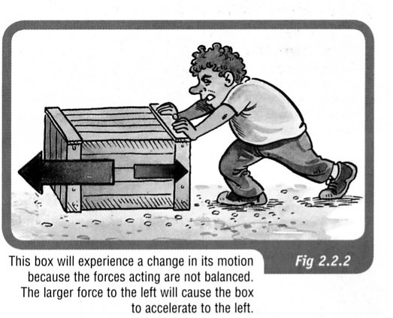

2. The force must be external.

Can you move a car by sitting inside it and pushing on the steering wheel?
Of course, the answer is no.

If you wanted to push a car, you would have to stand outside the car and
push it.

To fully understand how forces can do these things, one needs to understand Newton’s Three Laws of Motion.

NEWTON'S FIRST LAW

A body at rest or moving at constant velocity will continue
to do so unless acted upon by an external unbalanced force.

Example
The force needed to move an object appears to be dependent on the mass.
MASS
FORCE

The larger the mass, the greater the force required to move the object.

Newton's First Law is often referred to as the law of inertia.

Inertia is considered to be the property of a body which, when still, makes it hard to move and, when moving, keeps it going.

This property seems to be determined by mass - the greater the mass, the greater the inertia.

Examples

1. A train has a lot of inertia due to its large size. It takes a great deal of force to start it moving (if it's stationary) or stop it (if it's moving).

2. Consider a passenger in a car moving at 60.0 km/h. If the car brakes suddenly, the
passenger will continue to move forward at 60.0 km/h (due to inertia), until the seatbelt
exerts a force on them to slow them down.

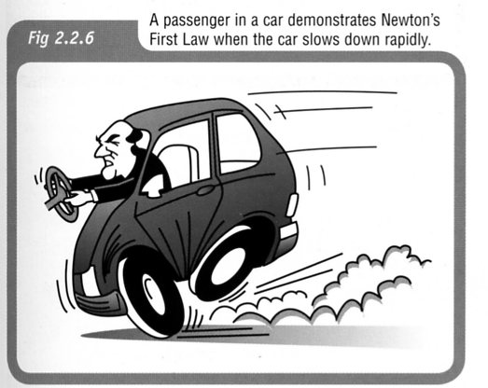

3. If a car accelerates quickly from a standing start, a passenger is thrown back in their seat. They want to stay stationary (due to inertia) and the car moves forwards under them.

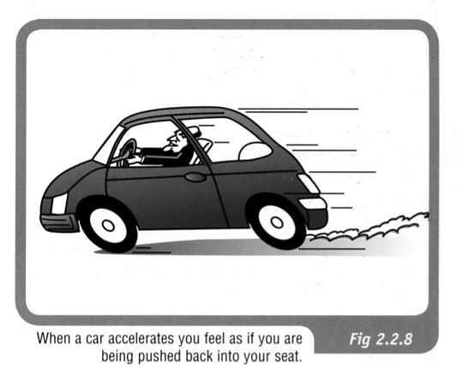

4. When a car turns a corner, the passengers have inertia that wants to keep them moving
straight ahead. The car moves under them and the passengers feel as if they are moving
(leaning) in the opposite direction to the turn.

Because of this, people assume a centrifugal force is acting on the passengers pushing them away from the corner.

THIS IS FALSE - THE "FORCE" DOESN'T EXIST!!

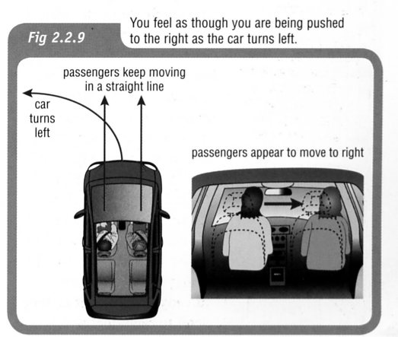

MORE ABOUT FORCES

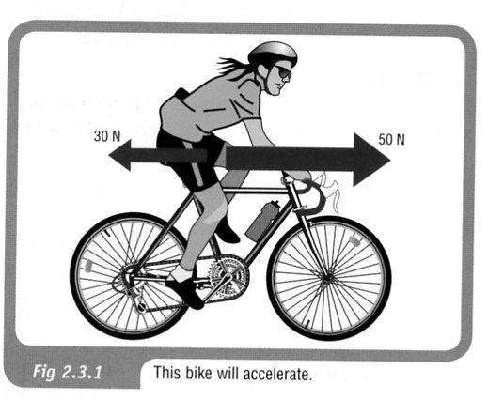
Unbalanced Forces

In the diagram at right, the bike experiences an unbalanced force of 20 Newtons in a forward direction.

The bike will therefore accelerate in a forward direction because of the effect of this unbalanced forward force.

To calculate the resultant force, take forwards as positive.

=> The force backwards is negative.

∴ ΣF = 50 - 30 = 20 N forwards.

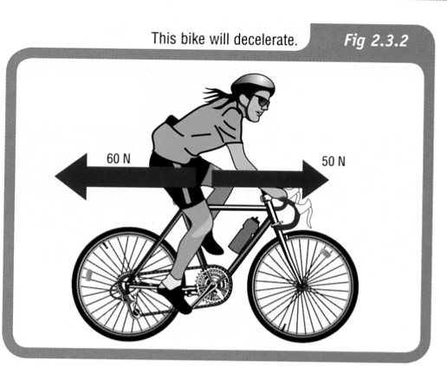

However, if the girl is not pedalling hard enough to overcome all the friction, the unbalanced force acting on the bike is 10 newtons in the opposite direction from the direction that the bike is moving.

The bike will therefore not be able to maintain a constant velocity but will decelerate.

Take forwards as positive.

ΣF = 50 - 60 = -10 N
the negative sign means the direction is backwards.

∴ ΣF = 10 N backwards.
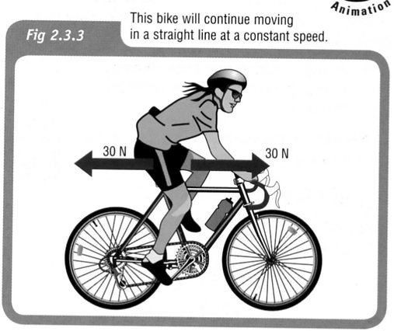

If the girl’s forward pedalling force is exactly the same
size as the frictional force in the opposite direction, there
is no unbalanced force acting on the bike.

The bike will not accelerate or decelerate but will
continue in a straight line with a constant
speed.

∴ ΣF = 0
NEWTON'S SECOND LAW

An external unbalanced force will cause an object to accelerate in the
direction of the resultant force.

This is represented by:
ΣF = ma

where ΣF = the resultant unbalanced force acting (N)
m = mass of the object (kg)
a = acceleration (ms⁻²)

Examples

1. What would be the acceleration of a skateboarder and her skateboard if their combined mass of 55.0 kg was acted on by an accelerating force of 60.0 N?

2. A car of mass 1100 kg is accelerated by a motor that provides a force of 3100 N.
A frictional force of 850 N opposes the motion of the car. Calculate the acceleration of
the car across the ground.
F_{friction} = 850 N
F_{engine} = 3100 N

Gravity and Weight

Most objects fall back to Earth due to gravity, one of the fundamental forces in the universe.

According to Isaac Newton, gravity is due to the attraction between two masses.

i.e. There is an attraction between you and the person next to you, your pens and pencils, the Earth, etc.

The attraction to the Earth is the strongest since its mass is so large
(5.98 x 10²⁴ kg).

Two terms need to be clearly distinguished.

Mass - amount of matter in an object (measured in kg).

Weight - force due to gravity on an object (measured in Newtons - N).

The mass of an object does not change throughout the universe while the weight will constantly change as it is moved from place to place.

As seen previously, the acceleration due to gravity on the earth's surface is:

g = 9.80 m/s²

The force due to weight (F_{w}) is given by:

F_{w} = mg
where g = the acceleration due to gravity (m/s²)

Example

The gravitational field on Jupiter is 2.50 times greater than that on Earth. If it was possible for a person of 80.0 kg to stand on Jupiter's surface, calculate their weight.

NEWTON'S THIRD LAW

For every action there is an equal and opposite reaction.

Newton realised that forces occur in pairs and act on different objects.

e.g. Consider a block sitting at rest on a table.

The force due to gravity (weight) acts downwards on the block. Thus the block exerts a force onto the table.

The table exerts an equal and opposite force to support it. The table exerts a force onto the block.

Examples

1. The player pushes on the ball (action) and the ball pushes back equally on his hand (reaction).

When the ball hits the ground, the ball pushes on the ground (action) while the ground pushes back equally (reaction).

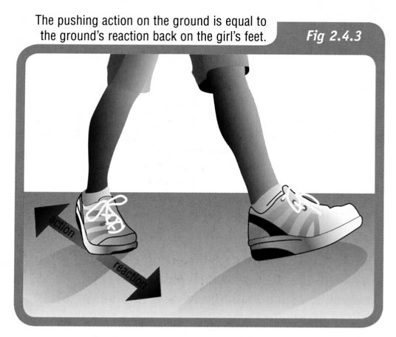

2. The girl is able to walk because friction allows
her to push backwards on the ground.

The ground in turn pushes back on her feet, by the same force but in the opposite direction.

3. The diagram shows the reaction chamber for
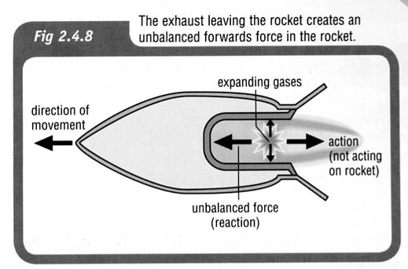
a rocket.

As the fuel burns, the expanding gases push in
all directions.

The gases rush out the exhaust outlet (action),
causing a push on the rocket (reaction) that
moves it forwards.

This unbalanced force is called thrust.

CHAPTER 8: Forces, energy and motion
Worksheet 8.4

Inertia and motion
Student: Class:
1. State Newton’s First Law of Motion.

2. Consider the following examples of forces acting on a body. In each case find the net (unbalanced) force and describe the resulting motion of the object. Assume north is up the page.
(a)
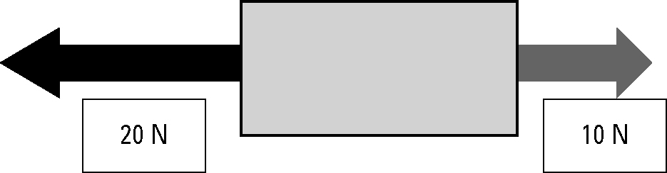
(b)
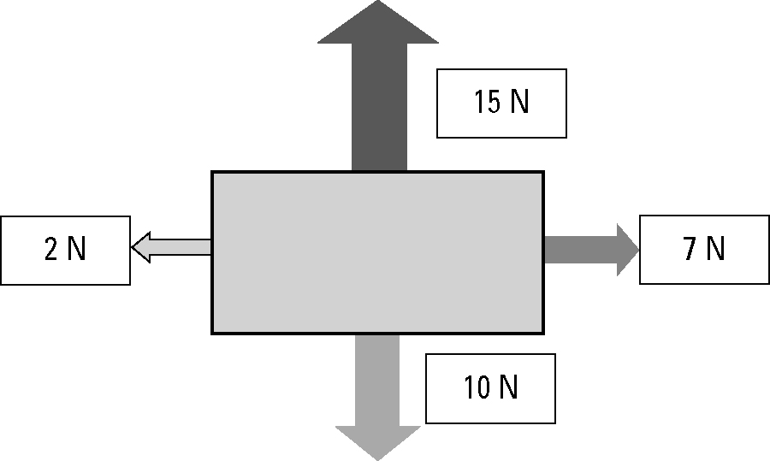
3. A 500 kg box is placed on the tray of a utility truck but is not secured by ropes. The ute drives along a highway, then the driver has to brake suddenly to avoid a wombat on the road. Use the concept of inertia to explain the danger to the driver.

4. A 1.0 kg pendulum is mounted on the roof of a vehicle as shown in the diagram.
 | 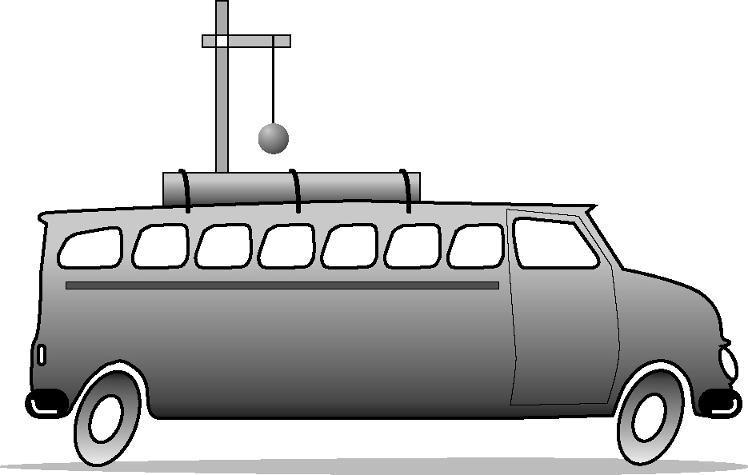 | Describe the motion of the pendulum for each example.  (a) The vehicle accelerates from rest.  (b) The vehicle brakes from a speed of  60 km/h.

CHAPTER 8: Forces, energy and motion
Worksheet 8.5

Force and gravity
Student: Class:

Weight
1. The weight of an object is the force acting on the object in a gravitational field. The stronger the gravitational field, the greater the weight of a body. Weight is measured in the units of newtons (N)
The weight (W) of a body of mass (m) in a gravitational field (g = acceleration due to gravity) is given by the formula:
W = mg
On the Earth’s surface ‘g’ typically has a value of 9.8 m/s² but this varies with altitude and latitude. On other planets, the value of ‘g’ also changes.
Complete the table using the above formula.
Mass (kg) | Gravity (m/s²) | Weight (N)
20 | 9.8
30 |  | 286.5
 | 9.8 | 400.0

Spreadsheets and graphing
2. A spreadsheet program such as Excel is a useful computer application for tabulating data and plotting graphs. In this exercise you will practise using a spreadsheet application.
The following mass and weight data was collected from the planet Mars. The data is presented as you would set it out in the spreadsheet application.
(a) Open the spreadsheet application and enter the data as tabulated below.
(b) Select Insert from the menu bar.
(c) Select Scatter as the chart type. Select ‘Scatter with straight lines and markers’.
(d) The Design and Layout tabs can be used to insert a chart title and then each axis title and unit.
(e) Select the gridlines you would like to show.
 | A | B
1 | Mass (kg) | Weight (N)
2 | 0.0 | 0.0
3 | 0.5 | 1.9
4 | 1.0 | 3.8
5 | 1.5 | 5.7
6 | 2.0 | 7.6
7 | 2.5 | 9.5
8 | 3.0 | 11.4
Use your chart to answer the following questions.
(f) Estimate the weight of a 1.3-kg body on the surface of Mars. ...................................
(g) Estimate the mass of an object that weighs 10.0 N on Mars. ....................................
(h) Suggest what information the slope of the graph may provide.
W = mg can be rearranged as g = | W | .)
 | m

(Clue: The formula

CHAPTER 8: Forces, energy and motion
Worksheet 8.6

Newton’s Second Law
Student: Class:
1. State Newton’s Second Law of Motion.

2. Use the formula F = ma to complete the following table
Force (F) (newtons) | Mass (m) | Acceleration (a)
100 | 40 kg
2 | 200 g
70 |  | 3.5 m/s²
100 |  | 10 cm/s²
3. Consider the forces acting on a body of mass 40 kg resting on a frictionless surface.
 | 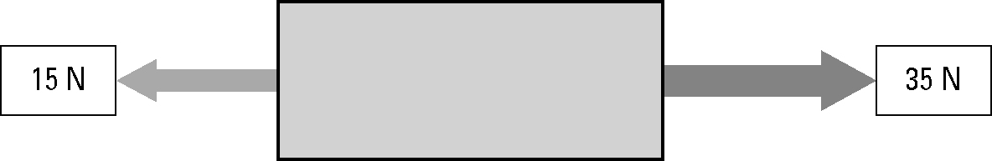 | (a) Calculate the net force acting  on the body.
(b) Calculate the acceleration of the body.

4. The photo shows a drag car coming to a stop at the end of a race.
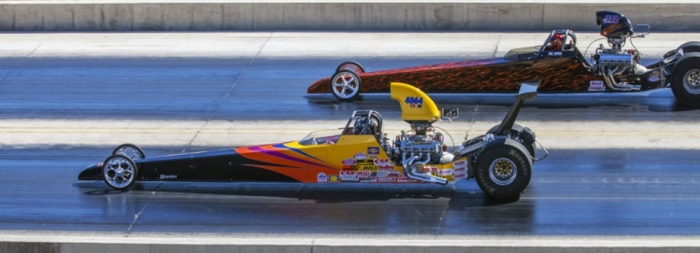
Photo: Claudia Schnepf / 123RF
(a) To come to a complete stop, the drag car negatively accelerates. Identify another term for ‘negative acceleration’. ...................................................................
(b) Identify the force that brings the drag car to a stop. .....................................................................

CHAPTER 8: Forces, energy and motion
Worksheet 8.7

Newton’s Third Law
Student: Class:
1. State Newton’s Third Law of Motion.

2. The following diagram shows a balloon rocket built by students to investigate motion. The balloon is mounted on a horizontal string using a length of drinking straw and masking tape.
 | 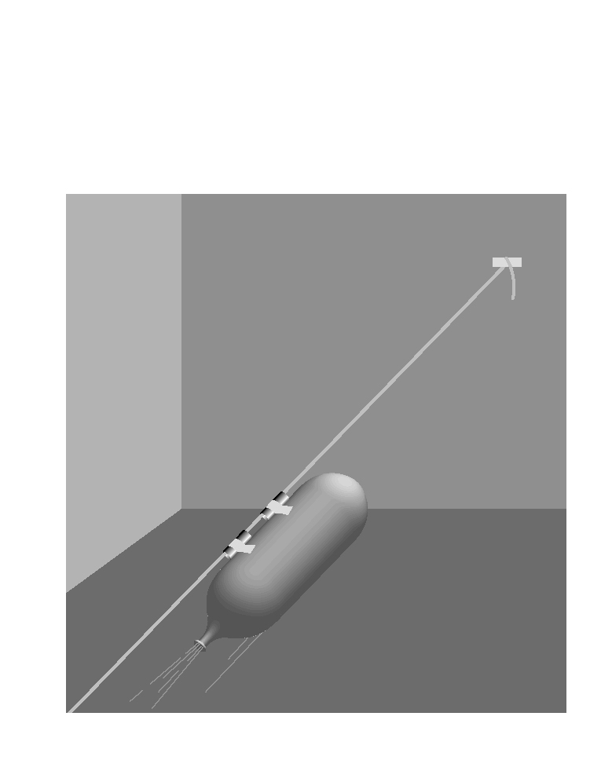 | The inflated balloon is then released.  (a) Where along the string will the balloon be moving at the greatest speed?  (b) Use Newton’s Third Law to explain why the balloon is propelled forward along the string.
3. The photograph below shows a person pushing against a wall.
Photo: Wavebreak Media Ltd / 123RF |  | The man is not moving even though he is pushing forward against the wall.  (a) What is the net force acting on the man?  (b) If the man pushes with a force of 200 N on the wall, what is the force that the wall exerts back on him?  (c) The man is pushing back on the floor with his feet with a force 200 N. With what force does the floor push back on the man?
(d) Explain what would happen if he tried to do this on a very slippery floor.

CHAPTER 8: Forces, energy and motion
Worksheet 8.8

Forces, energy and
motion: Summary
Student: Class:
Complete the statements below to compile a summary of this unit. The missing words can be found in the word list below.
1. Speed is a measure of the …………… at which an object moves over a distance.
2. …………… speed can be calculated by dividing the distance travelled by the time taken.
3. …………… is a measure of the rate of change in position. In order to describe the velocity fully, the …………… of the change in position must be stated.
4. The …………… speed of an object is its speed at a particular instant of time.
5. The …………… of an object moving in a straight line is a measure of the rate at which it changes speed.
6. The average acceleration of an object can be calculated by …………… the change in its speed by the time taken for the change.
7. The force of gravitational attraction to a large object such as a planet is called …………… .
8. An object will remain at rest, or will not change its speed or direction, unless it is acted upon by an outside, …………… force.
9. The acceleration of an object depends on the mass of the object and the …………… force acting on it.
10. When an object applies a force to a second object, the second object applies an …………… and …………… force to the first object.
11. …………… is done whenever a force is applied to an object and the object moves in the direction of the force.
12. …………… can be transferred to an object by doing work on it. Doing work on an object can also convert the energy an object possesses from one form into another.
13. All stored energy is called …………… energy. …………… potential energy and …………… potential energy are examples of stored energy.
14. The Law of Conservation of Energy states that energy is never created or …………… .

average | destroyed | potential | weight
energy | equal | total | opposite
direction | dividing | work | gravitational
unbalanced | instantaneous | acceleration
elastic | velocity | rate

Answers

CHAPTER 8: Forces, energy and motion
Speed and velocity

Worksheet 8.1

Answers

Calculating average speed
1. The average speed (v) for a journey is calculated using the formula:
v = | d
 | t
where d = distance travelled and t = time taken.
Complete the following table. Make sure you include the appropriate units for each quantity.
Distance travelled | Time taken | Average speed
100 m | 20 s | = 5 m/s
3 km | = 0.05 h | 60 km/h
20 × 15 = 300 m | 15 s | 20 m/s
2 km | = 80 s | 25 m/s

Average speed and average velocity
2. Two vehicles (X and Y) travel from A to C along different paths as shown in the diagram (not drawn to scale). X travels along the path ABC and vehicle Y travels along AC. The triangle ABC is a right-angled triangle. A is north of B.
 |  |  | 
Both vehicles take 70 s for the trip.
Perform the necessary calculations to complete the table.
Average speed of X | Average velocity of X | Average speed of Y | Average velocity of Y
d = 800 + 600  = 1400 m  t = 70 s  v = =  = 20 m/s | v =  =  = 14.3 m/s  Direction = 37 °S of E  (draw a scale diagram  and measure the  angle) | d(AC) = 1000 m (this  is a 3:4:5 right-angled  triangle)  t = 70 s  v = =  = 14.3 m/s | v =  =  = 14.3 m/s  Direction = 37 °S of E  (draw a scale diagram  and measure the  angle)

CHAPTER 8: Forces, energy and motion
Ticker tapes

Worksheet 8.2

Answers

Describing motion
1. For each ticker tape shown, describe the motion of the body to which the tape was attached.
The left-hand dot is at time zero.
(a)

The speed of the body is increasing with time. It is accelerating.
(b)

Initially, the body accelerates (its speed is increasing) and then rapidly decelerates (its speed is decreasing).

Measuring speed
2. The time between each of the dots on the following ticker tape is 0.02 s.

(a) Calculate the average speed of the object to which the tape was attached for each time interval. Express your answers in mm/s.
This is a sample calculation; student answers may vary depending on the magnification of the image.

Interval | Distance between dots (mm) | Average speed (mm/s)
AB | 38 | = 1900 mm/s
BC | 30 | = 1500 mm/s
CD | 25 | = 1250 mm/s
DE | 20 | = 1000 mm/s
EF | 14 | = 700 mm/s
FG | 7 | = 350 mm/s
(b) Describe the motion of the object to which this tape was attached.
The average speed of the object is decreasing with time. The object is decelerating.

CHAPTER 8: Forces, energy and motion

Worksheet 8.3

Acceleration
Answers
The velocities of two objects were recorded over ten-second time periods, as shown in the examples below.

Example: Gaining and losing speed
Time (s) | 0 | 1 | 2 | 3 | 4 | 5 | 6 | 7 | 8 | 9 | 10
Velocity  (m/s) | 0 | 2 | 4 | 6 | 8 | 10 | 12 | 11 | 10 | 9 | 8
1. (a) Use a spreadsheet application such as Excel to plot a line graph of this data.
(b) Format your graph. Ensure that the graph has a title and that each axis has a title and appropriate units. Use the graph to answer the following questions.
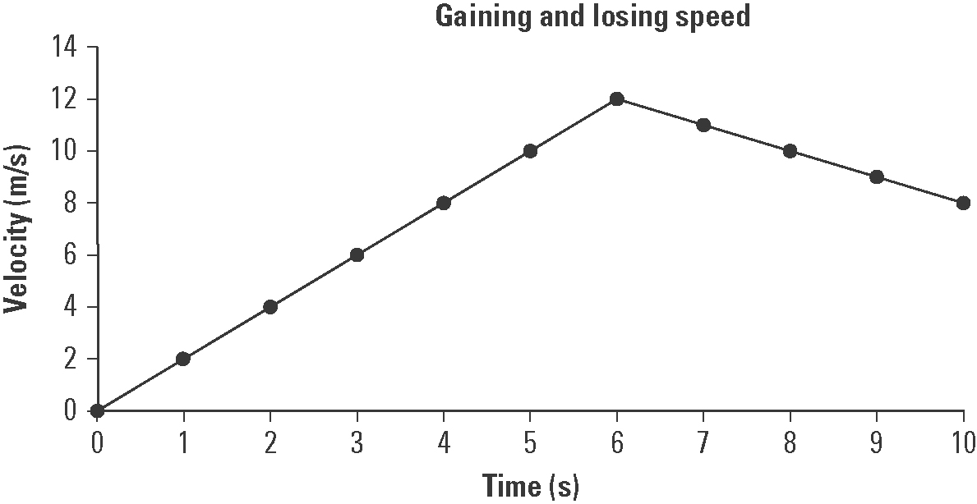

(c) Explain the shape of the graph.
The object accelerates uniformly for the first six seconds and then decelerates uniformly for the next four seconds.

(d) At the six-second mark the object’s speed begins to decrease. If the object’s speed continues to decline at the same rate after ten seconds, at what time will its velocity be zero?
At t = 18 seconds its velocity will be zero as its velocity is decreasing by 1 m/s every second.

Example: Falling down
Time (s) | 0 | 1 | 2 | 3 | 4 | 5 | 6 | 7 | 8 | 9 | 10
Velocity  (m/s) | 0 | 9.8 | 19.6 | 29.4 | 39.2 | 49.0 | 58.8 | 68.6 | 78.4 | 88.2 | 98.0
2. (a) Examine the data table and determine the pattern in the data. Use this pattern to complete the table.
(b) Use a spreadsheet application such as Excel to plot a line graph of this data.
(c) Format your graph. Ensure that the graph has a title and that each axis has a title and appropriate units. Use the graph to answer the following questions.
CHAPTER 8: Forces, energy and motion

Worksheet 8.3

Page 2

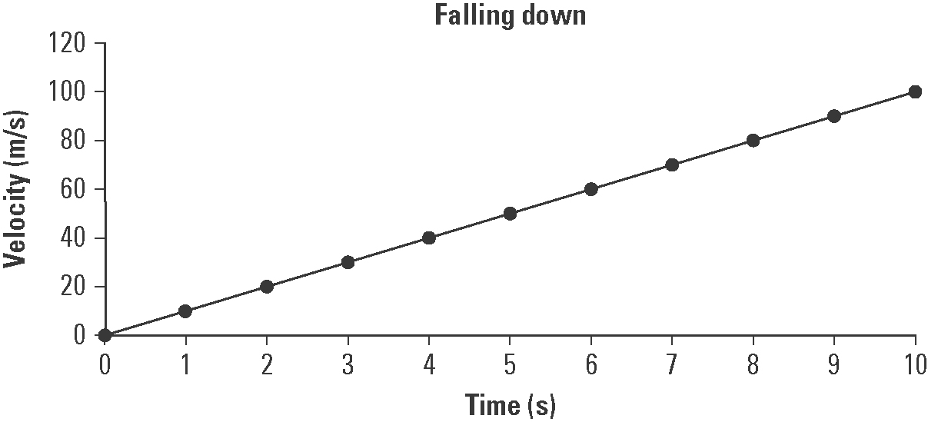

(d) Explain how this graph shows that falling due to gravity is an example of uniform acceleration.
The graph is linear with a constant slope. Thus, the falling object’s velocity is increasing at a uniform rate as would be expected for a body falling in a gravity field (as long as friction is absent or negligible).

(e) The slope of the graph is equal to the acceleration due to gravity. Determine the slope of the graph in m/s².
Slope = = = 9.8 m/s²

CHAPTER 8: Forces, energy and motion

Worksheet 8.4

Inertia and motion
Answers
1. State Newton’s First Law of Motion.
A body at rest will remain at rest and a body in motion will not change its speed or direction unless acted upon by an unbalanced force.

2. Consider the following examples of forces acting on a body. In each case find the net (unbalanced) force and describe the resulting motion of the object. Assume north is up the page.
(a)
The body will move to the left as the net force is 20 − 10 = 10 N to the left (i.e. west).

(b)
The body will move at 45° to the right of north (i.e. north-east). The net horizontal force is 7 − 2 = 5 N to the right (east). The net vertical force is 15 − 10 = 5 N up the page (north). The net result of these two equal forces is motion towards the north-east.

3. A 500-kg box is placed on the tray of a utility truck but it is not secured by ropes. The ute drives along a highway, then the driver has to brake suddenly to avoid a wombat on the road. Use the concept of inertia to explain the danger to the driver.
Inertia is a measure of a body’s resistance to a change in motion. The unsecured box is travelling with the same speed as the ute. When the ute suddenly brakes, the inertia of the heavy box will result in it continuing to move forward into the cabin of the ute. This could cause severe injury or death to the driver.

4. A 1-kg pendulum is mounted on the roof of a vehicle as shown in the diagram.
 |  | Describe the motion of the pendulum in each example.  (a) The vehicle accelerates from rest.  The bob will hang backwards towards the rear of the vehicle.  (b) The vehicle brakes from a speed of  60 km/h.  The bob will hang forward towards the front of the vehicle.

CHAPTER 8: Forces, energy and motion

Worksheet 8.5

Force and gravity
Answers

Weight
1. The weight of an object is the force acting on the object in a gravitational field. The stronger the gravitational field, the greater the weight of a body. Weight is measured in the units of Newtons (N)
The weight (W) of a body of mass (m) in a gravitational field (g = acceleration due to gravity) is given by the formula:
W = mg
On the Earth’s surface ‘g’ typically has a value of 9.8 m/s² but this varies with altitude and latitude. On other planets, the value of ‘g’ also changes.
Complete the table using the above formula.
Mass (kg) | Gravity (m/s²) | Weight (N)
20 | 9.8 | 20 × 9.8 = 196
30 | = 9.55 | 286.5
= 40.8 | 9.8 | 400.0

Spreadsheets and graphing
2. A spreadsheet program such as Excel is a useful computer application for tabulating data and plotting graphs. In this exercise you will practise using a spreadsheet application.
The following mass and weight data was collected from the planet Mars. The data is presented as you would set it out in the spreadsheet application.
(a) Open the spreadsheet application and enter the data as tabulated below.
(b) Select Insert from the menu bar.
(c) Select Scatter as the chart type. Select ‘Scatter with straight lines and markers’.
(d) The Design and Layout tabs can be used to insert a chart title and then each axis title and unit.
(e) Select the gridlines you would like to show.
 | A | B
1 | Mass (kg) | Weight (N)
2 | 0.0 | 0.0
3 | 0.5 | 1.9
4 | 1.0 | 3.8
5 | 1.5 | 5.7
6 | 2.0 | 7.6
7 | 2.5 | 9.5
8 | 3.0 | 11.4

CHAPTER 8: Forces, energy and motion

Worksheet 8.5

Page 2

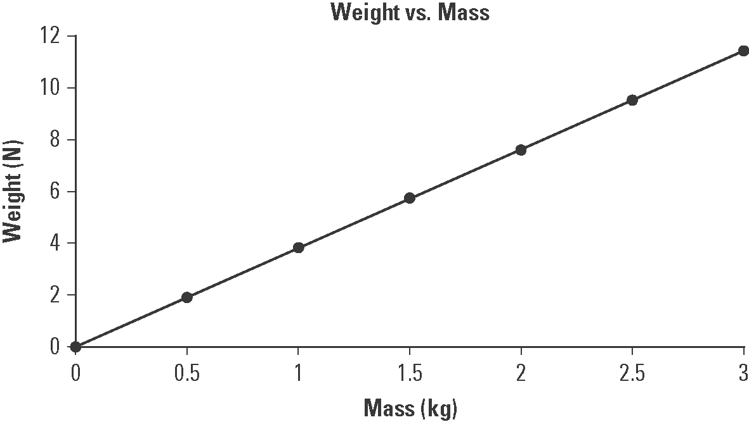

Use your chart to answer the following questions.
4.9 N
(f) Estimate the weight of a 1.3 kg body on the surface of Mars. ...................................
2.6 kg
(g) Estimate the mass of an object that weighs 10.0 N on Mars. ....................................
(h) Suggest what information the slope of the graph may provide.
W = mg can be rearranged as g = | W | .)
 | m

(Clue: The formula
The slope provides the acceleration due to gravity on the planet.

CHAPTER 8: Forces, energy and motion

Worksheet 8.6

Newton’s Second Law
Science Quest 10: pages 316–17
Answers
1. State Newton’s Second Law of Motion.
The acceleration of a body is directly proportional to the net force and inversely proportional to its mass.

2. Use the formula: F = ma to complete the following table
Force (F) (newtons) | Mass (m) | Acceleration (a)
100 | 40 kg | = 2.5 m/s²
2 | 200 g | = 10 m/s²
70 | = 20 kg | 3.5 m/s²
100 | = 1000 kg | 10 cm/s²
3. Consider the forces acting on a body of mass 40 kg resting on a frictionless surface.
 |  | (a) Calculate the net force acting  on the body.  F = 35 − 15 = 20 N
(b) Calculate the acceleration of the body.
a = = = 0.5 m/s²

4. The photo shows a drag car coming to a stop at the end of a race.
Photo: Claudia Schnepf / 123RF |   Photo: Claudia Schnepf / 123RF
(a) To come to a complete stop, the drag car negatively accelerates. Identify another term for ‘negative acceleration’. ...................................................................
Deceleration
Friction
(b) Identify the force that brings the drag car to a stop. .....................................................................

CHAPTER 8: Forces, energy and motion

Worksheet 8.7

Newton’s Third Law
Science Quest 10: pages 318–19
Answers
1. State Newton’s Third Law of Motion.
All forces occur in pairs; the forces are equal in magnitude but opposite in direction.

2. The following diagram shows a balloon rocket built by students to investigate motion. The balloon is mounted on a horizontal string using a length of drinking straw and masking tape.
 |  | The inflated balloon is then released.  (a) Where along the string will the balloon be moving at the greatest speed?  The greatest speed will occur when the balloon is initially released. This is when the force of the gas escaping is at its greatest and the reaction force acting on the balloon is at its greatest.  (b) Use Newton’s Third Law to explain why the balloon is propelled forward along the string.  The contracting rubber balloon pushes the air out of the open end of the balloon. The force of gases escaping from the balloon leads to a reaction force in which the gases push back on the balloon, which pushes it forward.
3. The photograph below shows a person pushing against a wall.
 |   Photo: Wavebreak Media Ltd / 123RF | The man is not moving even though he is pushing forward against the wall.  (a) What is the net force acting on the man?  Zero (he is not moving)  (b) If the man pushes with a force of 200 N on the wall, what is the force that the wall exerts back on him?  200 N (but in the opposite direction)  (c) The man is pushing back on the floor with his feet with a force 200 N. With what force does the floor push back on the man?  200 N (but in the opposite direction)
(d) Explain what would happen if he tried to do this on a very slippery floor.
As he pushes back against the slippery floor the lack of friction causes his foot to slide as the reaction force of the floor back on the shoe is too low. The low value of this force and the force of the wall pushing back on the man will cause him to fall down.

CHAPTER 8: Forces, energy and motion

Worksheet 8.8

Forces, energy and
motion: Summary
Answers
Complete the statements below to compile a summary of this unit. The missing words can be found in the word list below.
rate
1. Speed is a measure of the …………… at which an object moves over a distance.
Average
2. …………… speed can be calculated by dividing the distance travelled by the time taken.
Velocity
3. …………… is a measure of the rate of change in position. In order to describe the velocity fully, the …………… of the change in position must be stated.
direction
instantaneous
4. The ……………………… speed of an object is its speed at a particular instant of time.
acceleration
5. The ………………… of an object moving in a straight line is a measure of the rate at which it changes speed.
dividing
6. The average acceleration of an object can be calculated by …………… the change in its speed by the time taken for the change.
weight
7. The force of gravitational attraction to a large object like a planet is called …………… .
8. An object will remain at rest, or will not change its speed or direction, unless it is acted upon by an outside, ………………… force.
unbalanced
total
9. The acceleration of an object depends on the mass of the object and the …………… force acting on it.
equal
10. When an object applies a force to a second object, the second object applies an …………… and …………… force to the first object.
opposite
Work
11. …………… is done whenever a force is applied to an object and the object moves in the direction of the force.
Energy
12. …………… can be transferred to an object by doing work on it. Doing work on an object can also convert the energy an object possesses from one form into another.
potential
Gravitational
13. All stored energy is called …………… energy. ………………… potential energy and …………… potential energy are examples of stored energy.
destroyed
elastic
14. The Law of Conservation of Energy states that energy is never created or …………… .

average | destroyed | potential | weight
energy | equal | total | opposite
direction | dividing | work | gravitational
unbalanced | instantaneous | acceleration
elastic | velocity | rate

